Git Challenges
- Resolve Merge Conflicts
  - Create a merge conflict intentionally (two users editing the same line). Resolve the conflict and push the changes.
- First created two branches releases and vehicles and create file named Tata and enter same content in both files. Now try to merge. It will through an error as we can see in the below screenshot.

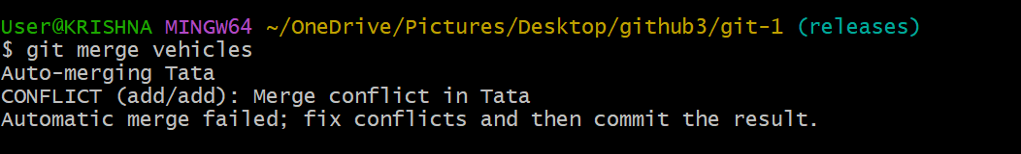
- Now edit a file any one branch and change the content in file. Now we can merge the branch
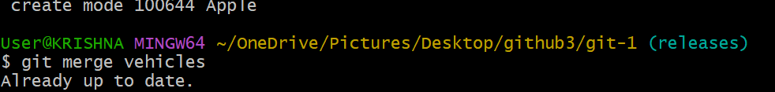
- Recover Deleted Branch: Delete a local branch and then recover it using the reflog.
- Using git branch -D deleted vehicles branch.
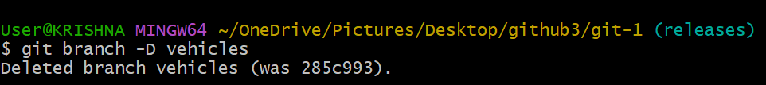

- Now using git reflog and commit id above. Use command git branch vehicle 285c993. Now we can see restored branch

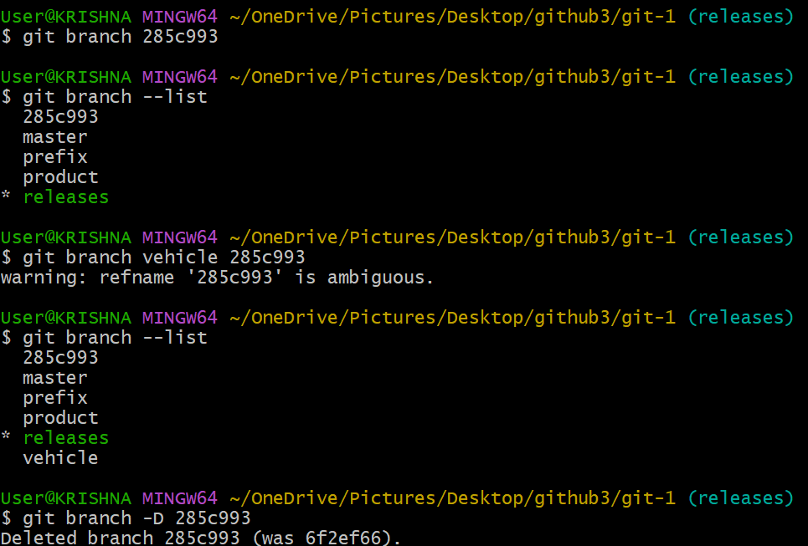

- Undo Wrong Push
  - Push a wrong commit to GitHub, then undo it without losing history.
  - Created an file named truefile and git add ., git commit, git push. Now by using commit id and git revert command I can bring the wrong push.
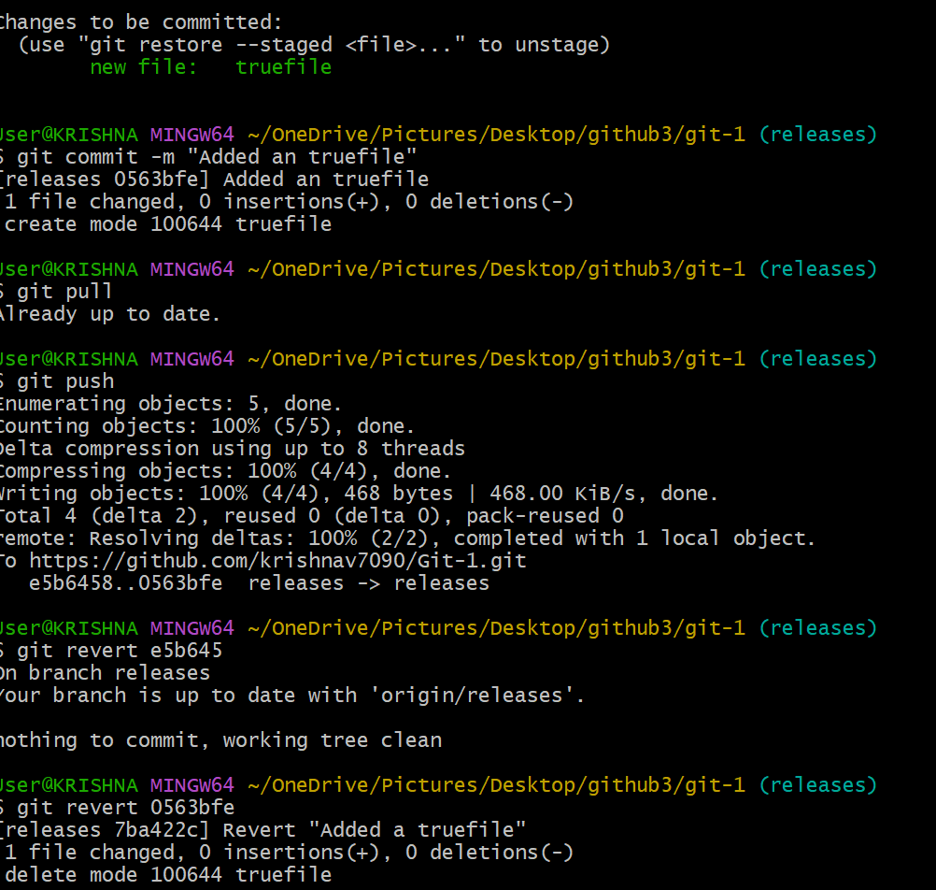
- Amend a Commit
  - Make a commit, then add a missing file to it using git commit --amend.
  - Created an file hi and added some content in it. Now I used git add. , git status, git commit -m. now to do some changes in it I use command git commit –amend.
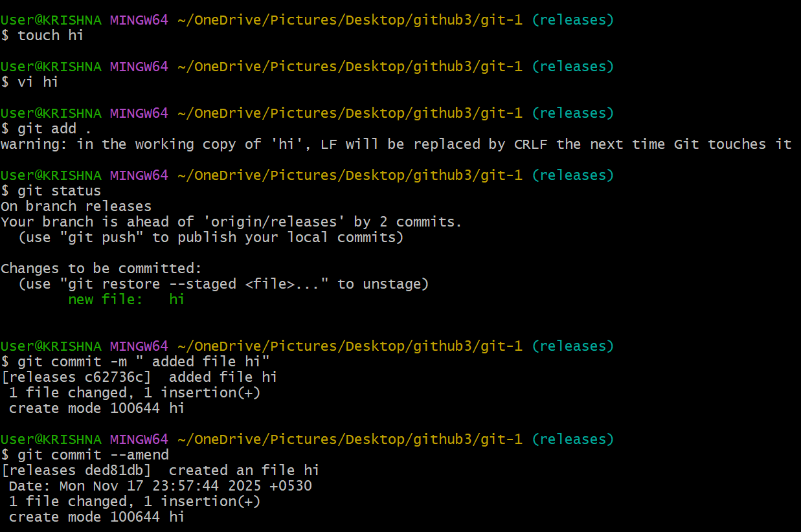
- Cherry-pick a Commit
  - Take a specific commit from one branch and apply it to another branch.
  - It is used to specific file from one branch to another using commit id.
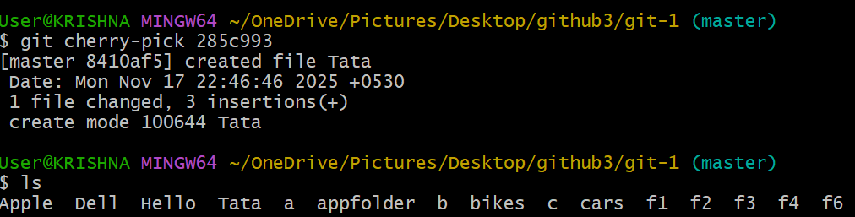
- Interactive Rebase
  - Reorder and squash multiple commits into a single clean commit.
  - By using command git rebase -I head~5 enter it navigates to vi editer in their replace the pick to squash except first line remaining four to merge the commits. Now its merged and all the commits comes with one commit id.
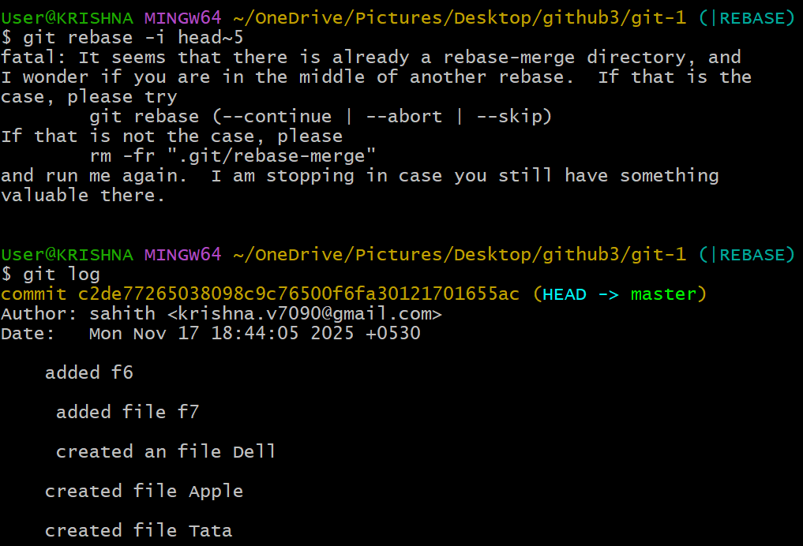
- Tagging & Release
  - Create a version tag (v1.0), push it to GitHub, then delete and restore it.
  - Using command git tag v1.0 create an version, use git tag to check the version
  - Git push origin v1.0 use this command to push to remote repo
  - Next, to delete the tag local use command git tag -d v1.0 and use git tag to check status.
  - To delete in github remote use command git push origin –delete v1.0
  - To restore the tag again use git reflog, use git tag v1.o commit id to recreate tag and check the status using git tag.
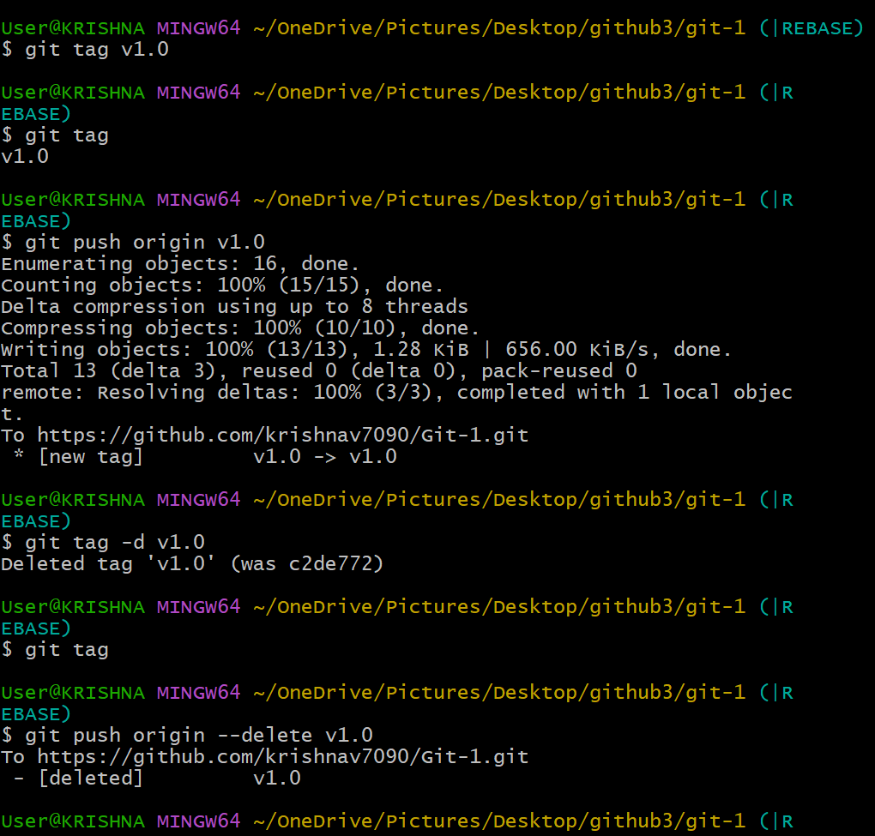
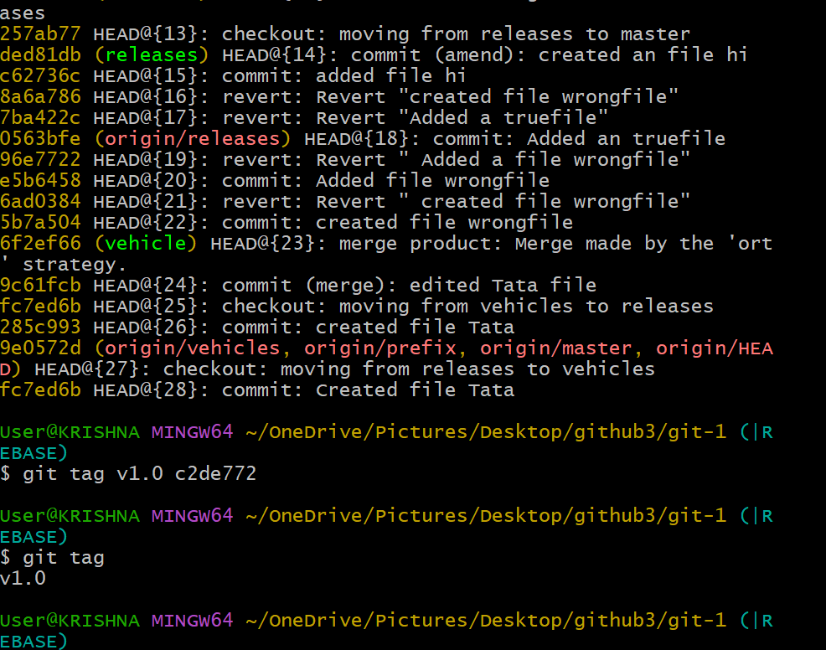
- Clone with Sparse Checkout
  - Clone only a subdirectory of a repo using sparse checkout.
  - Use git sparse -checkout init and git sparse-checkout set motors.

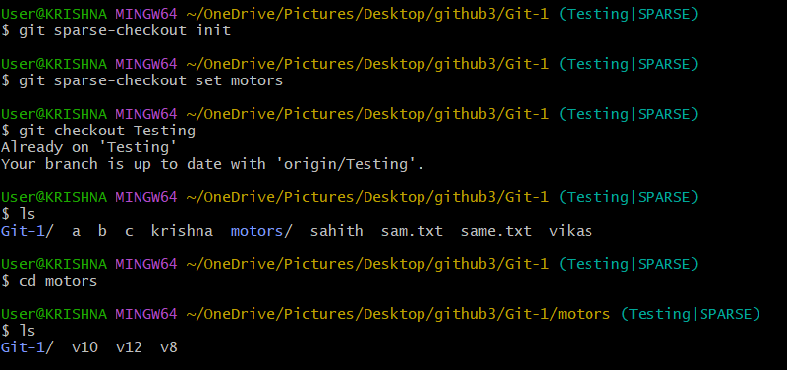
- Reset vs Revert Challenge
  - Demonstrate the difference between git reset --hard and git revert in a repo.
  - Git reset is used to move files from tracking to untracking. and git revert is used to uncommit the commited files. But, keep history clean. Git reset –hard it moves back the branch backwards and deletes the changes in the working directory and staging area. But, deletes everything after that commit.
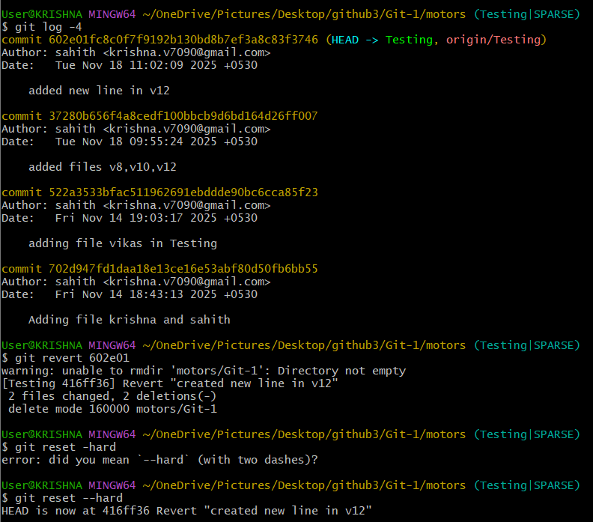
- Detached HEAD Challenge
  - Checkout a specific commit (detached HEAD state) and create a new branch from it.
  - Detached is used to checkout a specific commit (detached head state) and create a new branch from it
  - Using git checkout commitid and after detached head states and using git checkout -b new branch name. to create new branch.
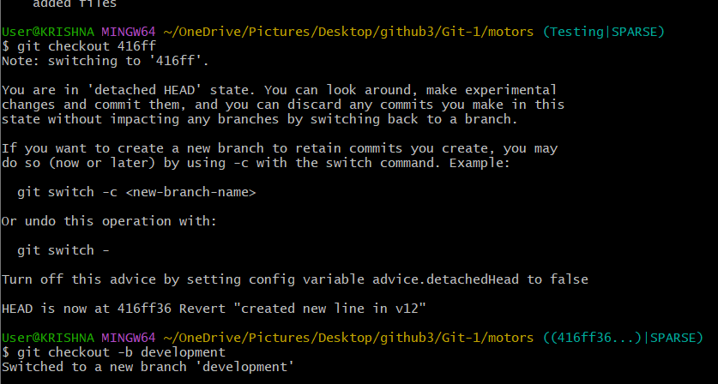
- Git Hooks Challenge
  - Configure a pre-commit hook to reject commits without a message format (e.g., must start with JIRA-XXX).
- Squash Merge vs Rebase Merge
  - Show the difference between squash merge and rebase merge with evidence.
  - Created an new branch demosquash and created an file test and enter and some text in it. Now used git add, git coomit -m. again repeated same process for multipule commits.
  - Now checkout to master and used git merge –squash demosquash and commited squash result. Now we can see the logs by git log –oneline.
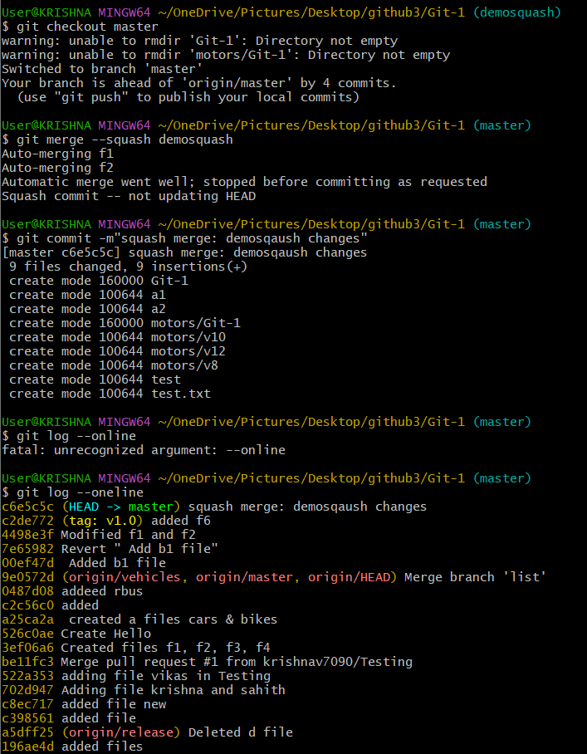
- Rebase merge
- First new branch called demorebase and entered text content in file rebusand git add, git commit -m and repeated one more time same process for multiple commits.
- Checkout to master and checkout to demorebase and git rebase master. Now to chek use command git log –oneline –graph.
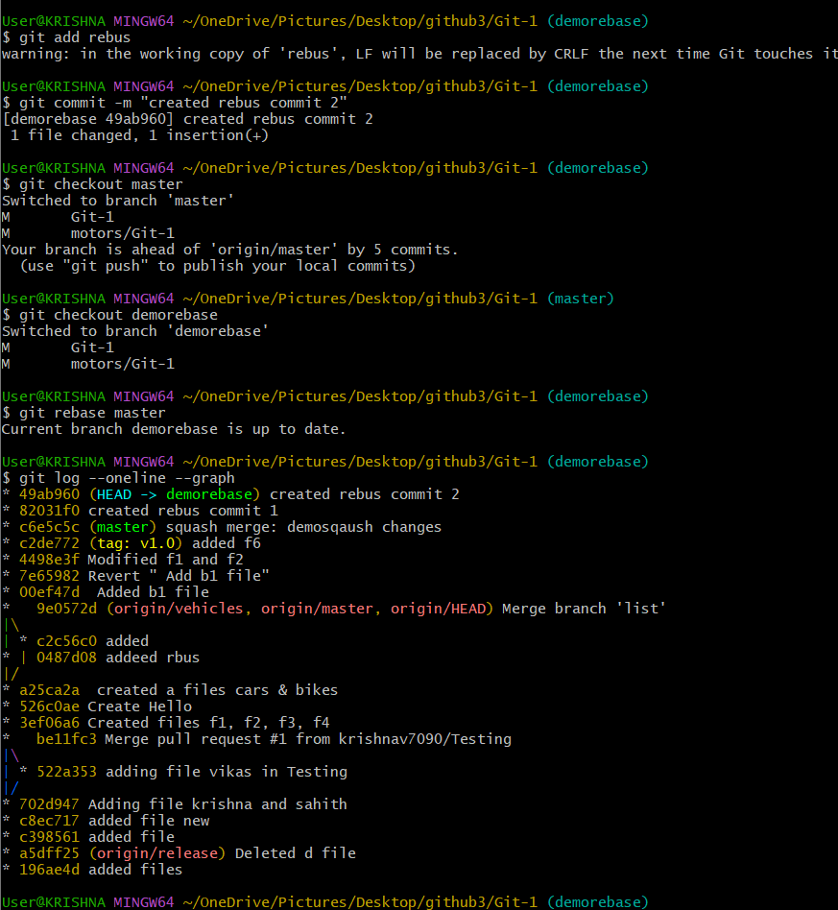
- Fork & Pull Request Workflow
  - Fork a repo, make a change, and submit a pull request to the original repo.
  - Forked an repository copy someone else’s github repo into our githuband clone our fork locally
  - Make changes in our local fork and push the changes to your fork
  - Create a pull request requesting the original repo owner to merge your changes.
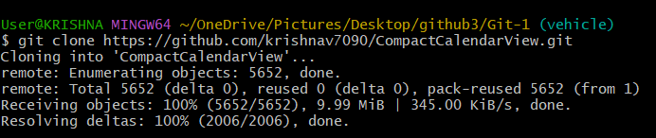
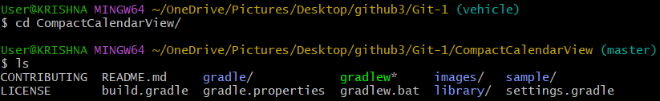
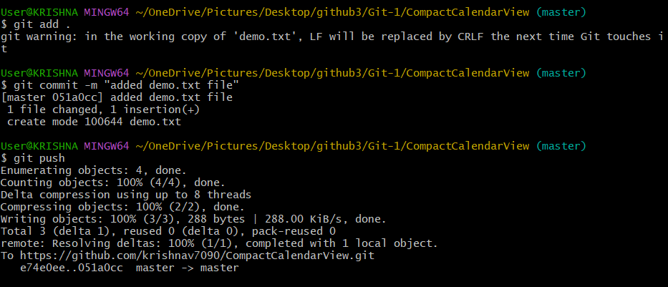
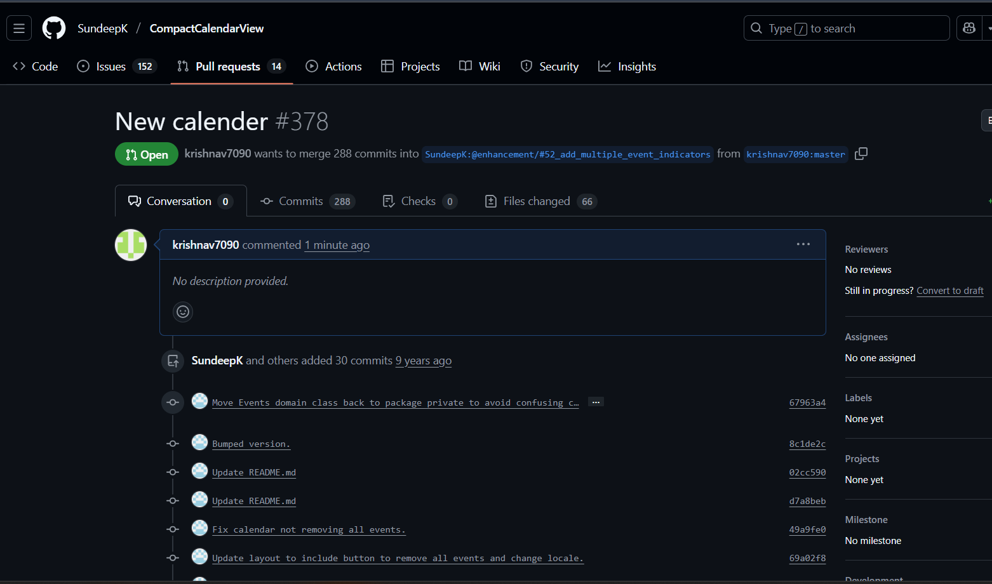
- Recover Lost Commit
  - Commit something, reset hard, and then recover it using git reflog.
  - Just added few lines for n existing file and git add,git commit -m commands are used. By using git log –online -1.
  - Reset hard to delete the commit using git reset --hard -HEAD~1
  - Now checks the commits using git log –oneline and git reflog
  - To restore the lost commit use git reset –hard commit id
  - By using git log –oneline we can confirm recovery.
